IT24104013

Manage M D N S

PS – LabSheet 08

Exercise

Question 01

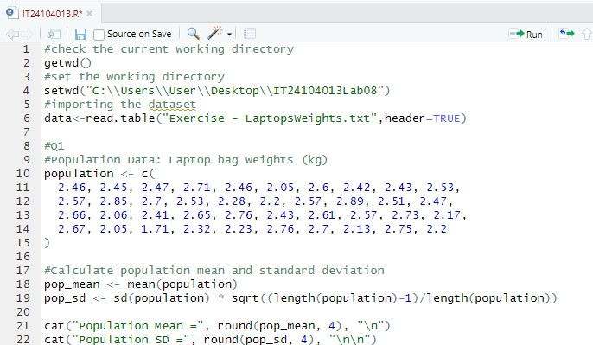

Question 02

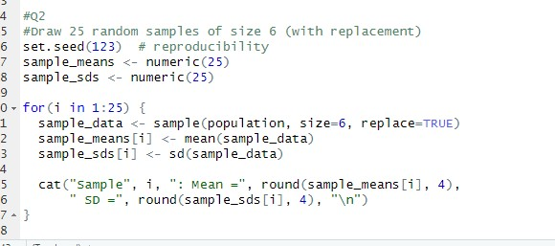

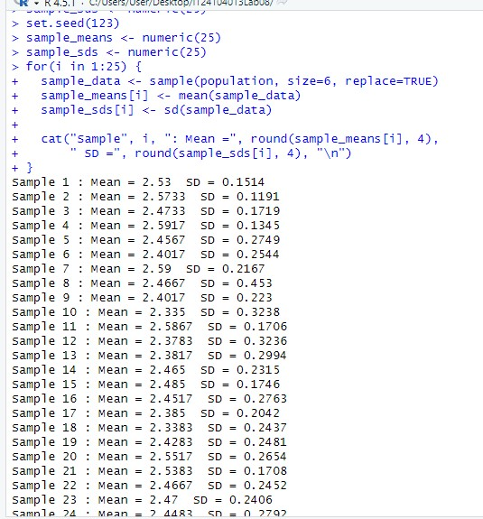



Question 03



